Markowitz Model
(Mean-Variance Optimisation)

The notion of diversification is age-old “don't put your eggs in one basket”, obviously predates economic theory. However a formal model showing how to make the most of the power of diversification was not devised until 1952, a feat for which Harry Markowitz eventually won Nobel Prize in economics.
Markowitz portfolio shows that as you add assets to an investment portfolio the total risk of that portfolio - as measured by the variance (or standard deviation) of total return - declines continuously, but the expected return of the portfolio is a weighted average of the expected returns of the individual assets. In other words, by investing in portfolios rather than in individual assets, investors could lower the total risk of investing without sacrificing return.

Introduction of the Markowitz Portfolio Selection Model

Harry Markowitz (1952, 1959) developed his portfolio-selection technique, which came to be called modern portfolio theory (MPT). Prior to Markowitz's work, security-selection models focused primarily on the returns generated by investment opportunities. Standard investment advice was to identify those securities that offered the best opportunities for gain with the least risk and then construct a portfolio from these. Following this advice, an investor might conclude that railroad stocks all offered good risk-reward characteristics and compile a portfolio entirely from these. The Markowitz theory retained the emphasis on return; but it elevated risk to a coequal level of importance, and the concept of portfolio risk was born. Whereas risk has been considered an important factor and variance an accepted way of measuring risk, Markowitz was the first to clearly and rigorously show how the variance of a portfolio can be reduced through the impact of diversification, he proposed that investors focus on selecting portfolios based on their overall risk-reward characteristics instead of merely compiling portfolios from securities that each individually have attractive risk-reward characteristics.
A Markowitz portfolio model is one where no added diversification can lower the portfolio's risk for a given return expectation (alternately, no additional expected return can be gained without increasing the risk of the portfolio). The Markowitz Efficient Frontier is the set of all portfolios of which expected returns reach the maximum given a certain level of risk.

The Markowitz model is based on several assumptions concerning the behavior of investors and financial markets:
- A probability distribution of possible returns over some holding period can be estimated by investors.
- Investors have single-period utility functions in which they maximize utility within the framework of diminishing marginal utility of wealth.
- Variability about the possible values of return is used by investors to measure risk.
- Investors care only about the means and variance of the returns of their portfolios over a particular period.
- Expected return and risk as used by investors are measured by the first two moments of the probability distribution of returns-expected value and variance.
- Return is desirable; risk is to be avoided.
- Financial markets are frictionless.

Measurement of Risk and Return

Throughout this chapter, investors are assumed to measure the level of return by computing the expected value of the distribution, using the probability distribution of expected returns for a portfolio. Risk is assumed to be measurable by the variability around the expected value of the probability distribution of returns. The most accepted measures of this variability are the variance and standard deviation.
Return
Given any set of risky assets and a set of weights that describe how the portfolio investment is split, the general formulas of expected return for n assets is:
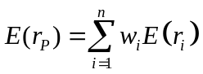 (X.1)
where:
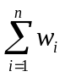 | = | 1.0;
n | = | the number of securities;
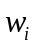 | = | the proportion of the funds invested in security i;
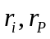 | = | the return on ith security and portfolio p; and
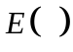 | = | the expectation of the variable in the parentheses.
The return computation is nothing more than finding the weighted average return of the securities included in the portfolio.

Risk
The variance of a single security is the expected value of the sum of the squared deviations from the mean, and the standard deviation is the square root of the variance. The variance of a portfolio combination of securities is equal to the weighted average covariance of the returns on its individual securities:
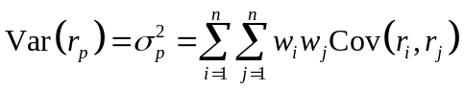 (X.2)
Covariance can also be expressed in terms of the correlation coefficient as follows:
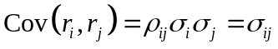 (X.3)
where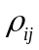= correlation coefficient between the rates of return on security i,, and the rates of return on security j,, and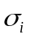, and 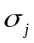represent standard deviations ofandrespectively. Therefore:
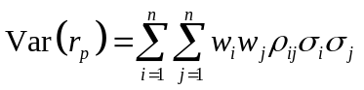 (X.4)
Overall, the estimate of the mean return for each security is its average value in the sample period; the estimate of variance is the average value of the squared deviations around the sample average; the estimate of the covariance is the average value of the cross-product of deviations.

Efficient Portfolio
Efficient portfolios may contain any number of asset combinations. We examine efficient asset allocation by using two risky assets for example. After we understand the properties of portfolios formed by mixing two risky assets, it will be easy to see how portfolio of many risky assets might best be constructed.

Two-risky-assets portfolio
Because we now envision forming a -portfolio from two risky assets, we need to understand how the uncertainties of asset returns interact. It turns out that the key determinant of portfolio risk id the extent to which the returns on the two assets tend to vary rather in tandem or in opposition. The degree to which a two-risky-assets portfolio reduces variance of returns depends on the degree of correlation between the returns of the securities.
Suppose a proportion denoted by 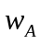 is invested in asset A, and the remainder 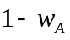, denoted by 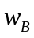, is invested in asset B. The expected rate of return on the portfolio is a weighted average of the expected returns on the component assets, with the same portfolio proportions as weights.
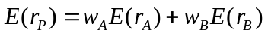 (X.5)
The variance of the rate of return on the two-asset portfolio is
(X.6)
where 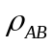 is the correlation coefficient between the returns on asset A and asset B. If the correlation between the component assets is small or negative, this will reduce portfolio risk.
First, assume that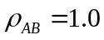, which would mean that Asset A and B are perfectly positively correlated, the right-hand side of equation X.6 is a perfect square and simplifies to
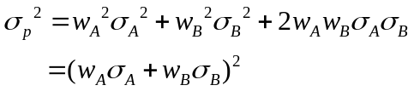
or
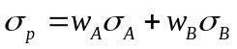
Therefore, the portfolio standard deviation is a weighted average of the component security standard deviations only in the special case of perfect positive correlation. In this circumstance, there are no gains to be had form diversification. Whatever the proportions of asset A and asset B, both the portfolio mean and the standard deviation are simple weighted averages. Figure X.1 shows the opportunity set with perfect positive correlation - a straight line through the component assets. No portfolio can be discarded as inefficient in this case, and the choice among portfolios depends only on risk preference. Diversification in the case of perfect positive correlation is not effective.
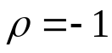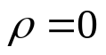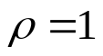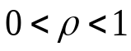
0
Standard Deviation
Expected Return
asset B
asset A
Figure X.1 Investment opportunity sets for asset A and asset B with various correlation coefficients
Perfect positive correlation is the only case in which there is no benefit from diversification. With any correlation coefficient less than 1.0(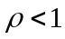), there will be a diversification effect, the portfolio standard deviation is less than the weighted average of the standard deviations of the component securities. Therefore, there are benefits to diversification whenever asset returns are less than perfectly correlated.
Our analysis has ranged from very attractive diversification benefits (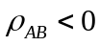) to no benefits at all 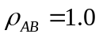. For within this range, the benefits will be somewhere in between.
Negative correlation between a pair of assets is also possible. Where negative correlation is present, there will be even greater diversification benefits. Again, let us start with an extreme. With perfect negative correlation, we substitute 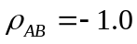 in equation X.6 and simplify it in the same way as with positive perfect correlation. Here, too, we can complete the square, this time, however, with different results.
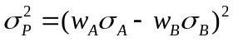
And, therefore,
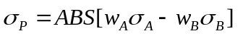 (X.7)
With perfect negative correlation, the benefits from diversification stretch to the limit. Equation X.7 points to the proportions that will reduce the portfolio standard deviation all the way to zero.
An investor can reduce portfolio risk simply by holding instruments which are not perfectly correlated. In other words, investors can reduce their exposure to individual asset risk by holding a diversified portfolio of assets. Diversification will allow for the same portfolio return with reduced risk.

The concept of Markowitz efficient frontier
Every possible asset combination can be plotted in risk-return space, and the collection of all such possible portfolios defines a region in this space. The line along the upper edge of this region is known as the efficient frontier. Combinations along this line represent portfolios (explicitly excluding the risk-free alternative) for which there is lowest risk for a given level of return. Conversely, for a given amount of risk, the portfolio lying on the efficient frontier represents the combination offering the best possible return. Mathematically the efficient frontier is the intersection of the set of portfolios with minimum variance and the set of portfolios with maximum return.
Figure X.2 shows investors the entire investment opportunity set, which is the set of all attainable combinations of risk and return offered by portfolios formed by asset A and asset B in differing proportions. The curve passing through A and B shows the risk-return combinations of all the portfolios that can be formed by combining those two assets. Investors desire portfolios that lie to the northwest in Figure X.2. These are portfolios with high expected returns (toward the north of the figure) and low volatility (to the west).
A
Minimum Variance Portfolio (MVP)
0
B
B’
Investment
Opportunity
Set
V
Standard Deviation
Expected Return
Z
Figure X.2 Investment opportunity set for asset A and asset B
The area within curve BVAZ is the feasible opportunity set representing all possible portfolio combinations. Portfolios that lie below the minimum-variance portfolio (point V) on the figure can therefore be rejected out of hand as inefficient. The portfolios that lie on the frontier VA in Figure X.2would not be likely candidates for investors to hold. Because they do not meet the criteria of maximizing expected return for a given level of risk or minimizing risk for a given level of return. This is easily seen by comparing the portfolio represented by points B and B’. Since investors always prefer more expected return than less for a given level of risk, B’ is always better than B. Using similar reasoning, investors would always prefer B to V because it has both a higher return and a lower level of risk. In fact, the portfolio at point V is identified as the minimum-variance portfolio; since no other portfolio exists that has a lower standard deviation. The curve VA represents all possible efficient portfolios and is the efficient frontier, which represents the set of portfolios that offers the highest possible expected rate of return for each level of portfolio standard deviation.
0
Efficient frontier of risky assets
Standard Deviation
Expected Return
Individual assets
Minimum variance
portfolio
Figure X.3 The efficient frontier of risky assets and individual assets
Any portfolio on the down ward sloping potion of the frontier curve is dominated by the portfolio that lies directly above it on the upward sloping portion of the frontier curve since that portfolio has higher expected return and equal standard deviation. The best choice among the portfolios on the upward sloping portion of the frontier curve is not as obvious, because in this region higher expected return is accompanied by higher risk. The best choice will depend on the investor’s willingness to trade off risk against expected return.
Calculating the Minimum variance portfolio
In Markowitz portfolio model, we assume investors choose portfolios based on both expected return, 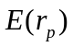, and the standard deviation of return as a measure of its risk, 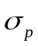. So, the portfolio selection problem can be expressed as maximizing the return with respect to the risk of the investment (or, alternatively, minimizing the risk with respect to a given return, hold the return constant and solve for the weighting factors that minimize the variance).
Mathematically, the portfolio selection problem can be formulated as quadratic program. For two risky assets A and B, the portfolio consists of 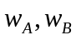, the return of the portfolio is then, The weights should be chosen so that (for example) the risk is minimized, that is
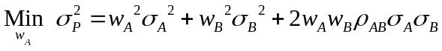
for each chosen return and subject to 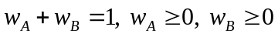. The last two constraints simply imply that the assets cannot be in short positions.
The minimum variance portfolio weights are shown in Table X.1, the detail proofs are in Appendix B.

Table X.1 The mimimum variance portfolio weight of two-assets portfolio without short selling
The correlation of two assets | Weight of Asset A | Weight of Asset B
ρ= 1 | 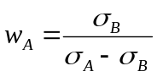 | 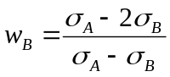
ρ= -1 | 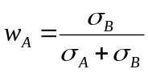 | 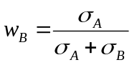
ρ= 0 | 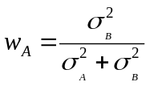 | 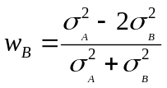
Above, we simply use two-risky-assets portfolio to calculate the minimum variance portfolio weights. If we generalise to portfolios containing assets, the minimum portfolio weights can then be obtained by minimising the Lagrange function C for portfolio variance.
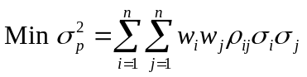
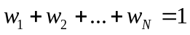
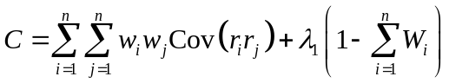 (X.8)
in whichare the Lagrange multipliers, respectively, is the correlation coefficient between and , and other variables are as previously defined.
By using this approach the minimum variance can be computed for any given level of expected portfolio return (subject to the other constraint that the weights sum to one). In practice it is best to use a computer because of the explosive increase in the number of calculations as the number of securities considered grows. The efficient set that is generated by the aforementioned approach (equation X.8) is sometimes called the minimum-variance set because of the minimizing nature of the Lagrangian solution.

Calculating the weights of optimal risky portfolio
One of the goals of portfolio analysis is minimizing the risk or variance of the portfolio. Previous section introduce the calculation of minimum variance portfolio, we minimum the variance of portfolio subject to the portfolio weights’ summing to one. If we add a condition into the equation X.8, whish is be subject to the portfolio’s attaining some target expected rate of return, we can get the optimal risky portfolio.
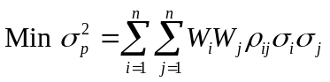
Subject to
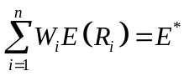, where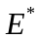is the target expected return and
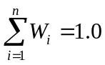
The first constraint simply says that the expected return on the portfolio should equal the target return determined by the portfolio manager. The second constraint says that the weights of the securities invested in the portfolio must sum to one.
The Lagrangian objective function can be written:
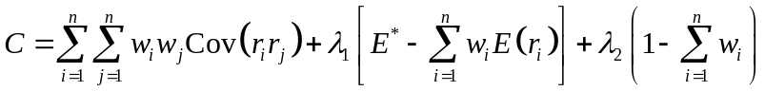 (X.9)
Taking the partial derivatives of this equation with respect to each of the variables,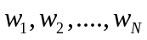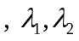and setting the resulting equations equal to zero yields the minimization of risk subject to the Lagrangian constraints. Then, we can solve the weights and these weights are represented optimal risky portfolio by using of matrix algebra.
If there no short selling constraint in the portfolio analysis, second constraint, 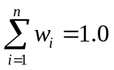, should substitute to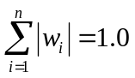, where the absolute value of the weights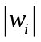allows for a givento be negative (sold short) but maintains the requirement that all funds are invested or their sum equals one.
The Lagrangian function is
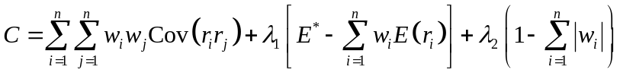 (X.10)
If the restriction of no short selling is in minimization variance problem, it needs to add a third constraint:
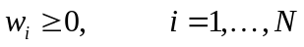
The addition of this non-negativity constraint precludes negative values for the weights (that is, no short selling). The problem now is a quadratic programming problem similar to the ones solved so far, except that the optimal portfolio may fall in an unfeasible region. In this circumstance the next best optimal portfolio is elected that meets all of the constraints.

Finding the efficient frontier of risky assets
According to two-fund separation, the efficient frontier of risky assets can be formed by any two risky portfolios on the frontier. All portfolios on the mean-variance efficient frontier can be formed as a weighted average of any two portfolios or funds on the efficient frontier, is called two-fund separation. So if we have any two points of the portfolio combinations, we can draw an entire efficient frontier of the risky assets. Previous sections we have introduced the minimum variance portfolio and optimal risky portfolio given the expected return, then, we can generate the entire efficient frontier by the separation property.
Deriving the efficient frontier may be quite difficult conceptually, but computing and graphing it with any number of assets and any set of constraints is quite straightforward.

References
Benninga Simon, 1999, Financial Modeling, The MIT press, Combridge, Massachusetts, London, England 1999.
Bodie Z., A. Kane ,and A. J. Marcus, 2003, Essentials of Investment, Fifth edition, xxxx:McGraw-Hill.
Bodie Z., A. Kane ,and A. J. Marcus, 2005, Investment, Sixth edition, McGraw-Hill.

Markowitz model assumes that investors are risk averse. This means that given two assets that offer the same expected return, investors will prefer the less risky one. Thus, an investor will take on increased risk only if compensated by higher expected returns. Conversely, an investor who wants higher returns must accept more risk. The exact trade-off will differ by investor based on individual risk aversion characteristics. The implication is that a rational investor will not invest in a portfolio if a second portfolio exists with a more favorable risk-return profile - i.e., if for that level of risk an alternative portfolio exists which has better expected returns. In order to form optimal portfolios, we initially split investors into prospect’s risk.
High covariance indicates that an increase in one stock's return is likely to correspond to an increase in the other. A low covariance means the return rates are relatively independent and a negative covariance means that an increase in one stock's return is likely to correspond to a decrease in the other.
The proofs of the slope and the shape of extreme correlation between asset A and asset B are in Appendix A.
The efficient frontier will be convex – this is because the risk-return characteristics of a portfolio change in a non-linear fashion as its component weightings are changed. (As described above, portfolio risk is a function of the correlation of the component assets, and thus changes in a non-linear fashion as the weighting of component assets changes.) The efficient frontier is a parabola (hyperbola) when expected return is plotted against variance (standard deviation).

